CIRCUIT CONNECTIONS, COMPONENTS & WORKING

1. System Block Diagram
The block diagram below shows how all inputs (battery, MQ-2 gas sensor, DHT11 Temperature Sensor, IR Flame Sensor,) and outputs (buzzer, OLED with I2C) connect through the central ESP32 microcontroller.
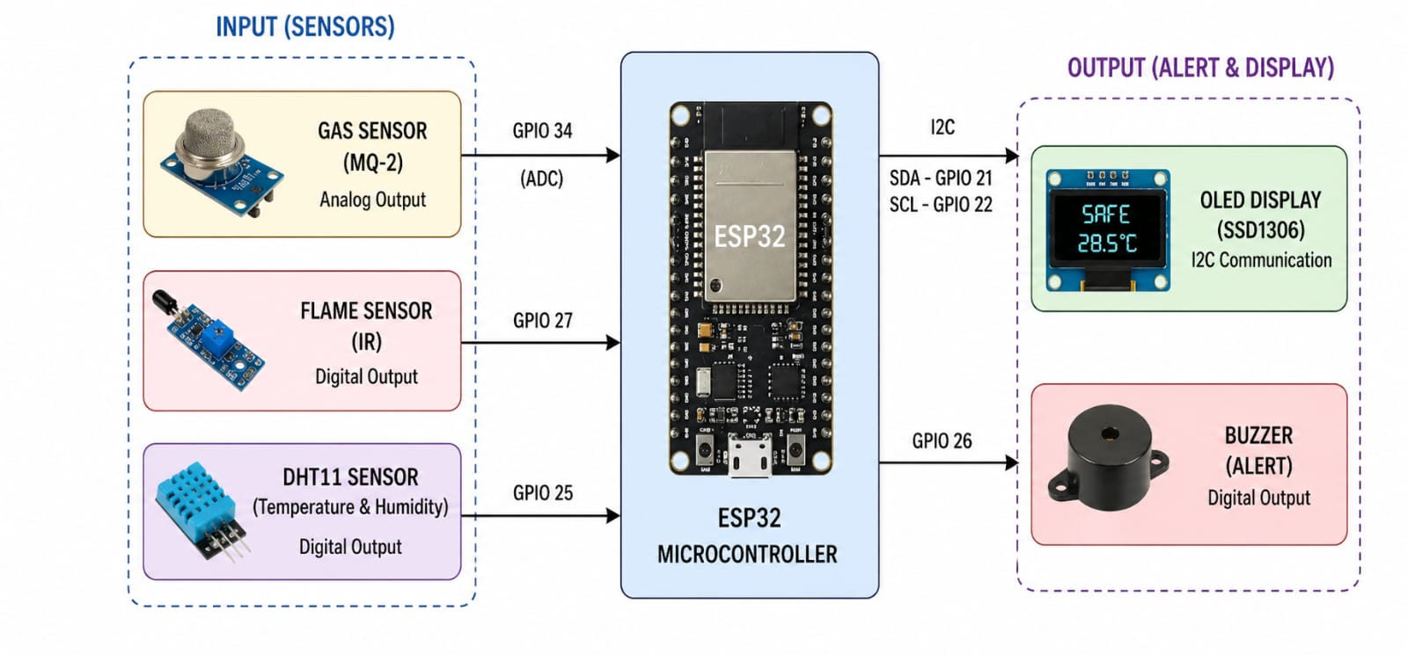
FIG. 3.3 EV Battery Monitoring System — Block Representation

2. Circuit / Schematic Diagram
The schematic diagram shows the exact GPIO pin connections between the ESP32 and each sensor/output module, along with the power distribution from the battery .
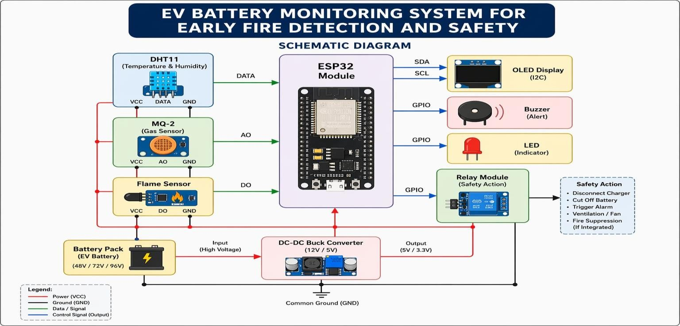
FIG. 3.4 EV Battery Monitoring system — Schematic Diagram

3. Actual Wired Prototype (Working Circuit Connection)
The photograph below shows the real, physically wired prototype corresponding to the schematic above — the ESP32, MQ-2 sensor,DHT11 Sensor ,flame sensor, and battery pack are connected exactly as per the circuit design and were used for all functional testing.
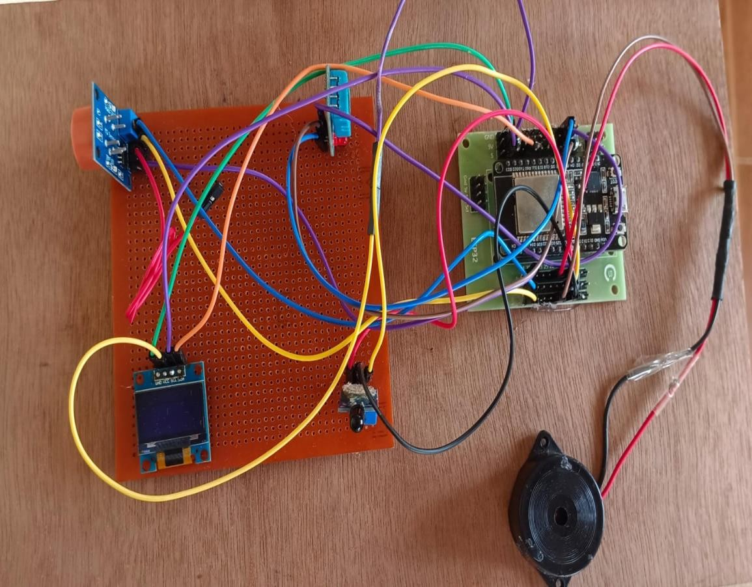
FIG. 3.5 Working Model of the Project — Actual Wired Connections

4. Hardware Components — Photos and Working
Each of the following components is shown with its photo, the GPIO pin(s) it connects to on the ESP32 (see the pin-connection table above), and a short description of its role and working in the overall circuit.
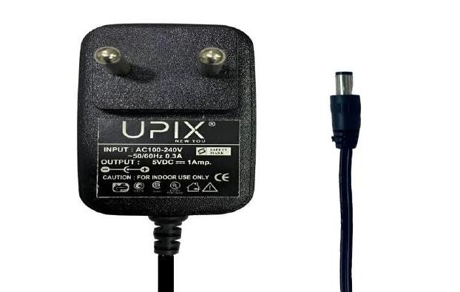 | 4.1 Power Supply — DC Power Adapter  A standard 5V DC adapter (AC-to-DC) supplies stable power to the ESP32 and associated components, either through the USB port or the VIN pin, suitable for testing, development, and lab demonstrations.

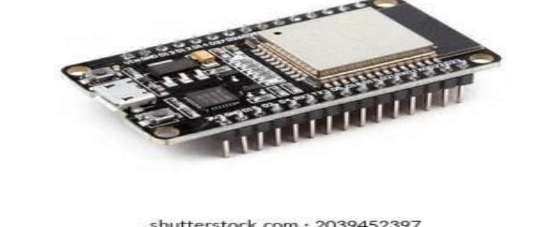 | 4.2 ESP32 Development Board  The core microcontroller of the system. Combines processing, Wi-Fi, and Bluetooth connectivity, coordinating all sensors and output modules (relay, buzzer, Telegram bot) via its GPIO pins.

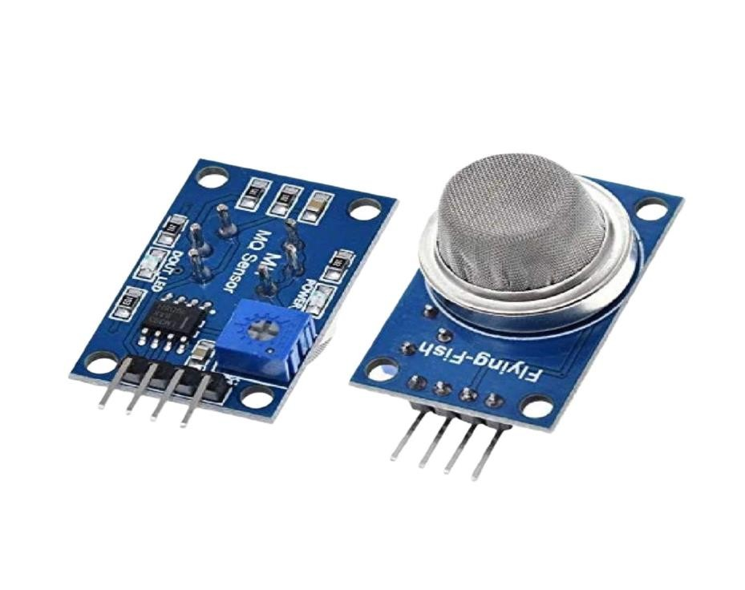 | 4.3 MQ-2 Gas Sensor  Connected to an analog GPIO (ADC) pin on the ESP32. Detects smoke and harmful gases when battery starts overheating or gets damaged

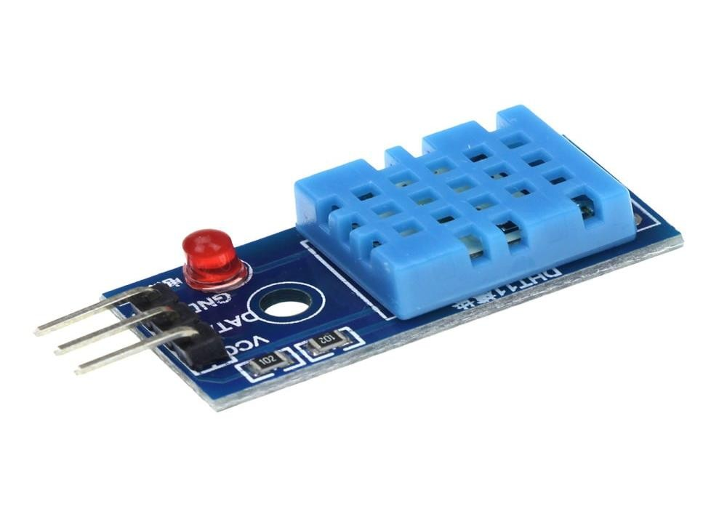 | 4.4 DHT11  Connected It measures the temperature and humidity using its internal sensing elements. If the temperature exceeds the set limit ,the ESP32 triggers a danger alert.

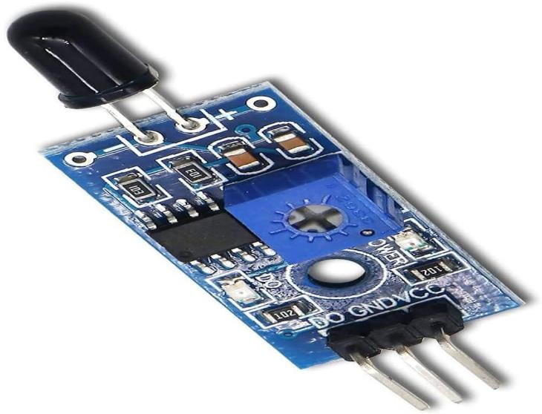 | 4.5 Flame Sensor  It acts as an additional safety layer if battery actually catches fire, the flame sensor can detect the flame and immediately trigger the alarm.

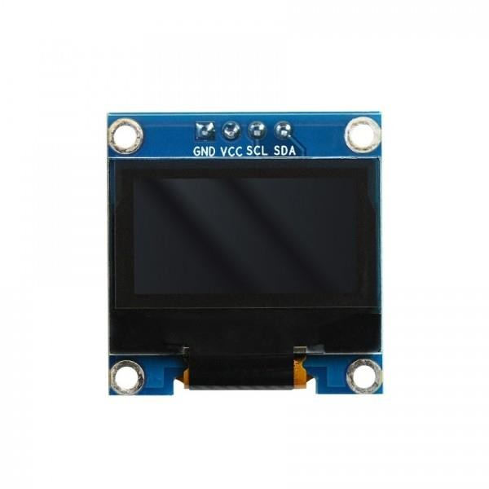 | 4.6 OLED  A DC-DC It is used to show sensor reaadibgs and system status. It receives data from the ESP32 and displayes values like temperature ,gas level, and falme status

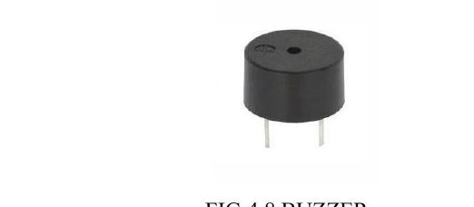 | 4.8 Buzzer  Connected to a digital output GPIO (GPIO15). Provides an immediate audible alert for conditions such as helmet not worn, alcohol detected, or accident detected.

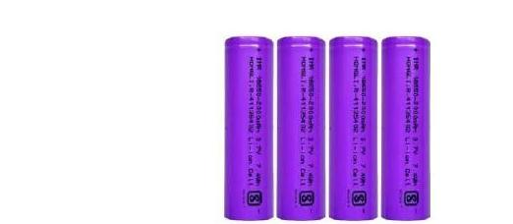 | 4.9 18650 Lithium-ion Battery  The rechargeable power source for the entire helmet circuit, feeding the buck converter / voltage regulator that powers the ESP32 and all connected sensors and modules.

5. ESP32 PIN DIAGRAM
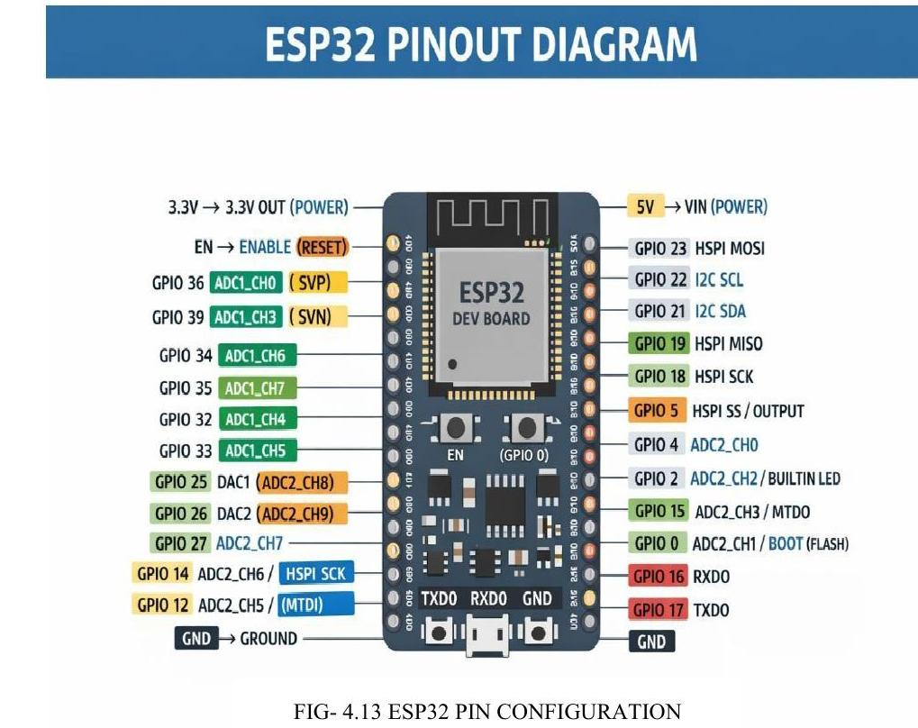
ESP32 Pin Configuration
IoT BASED SMART HELMET RIDER SAFETY SYSTEM
SCHEMATIC DIAGRAM

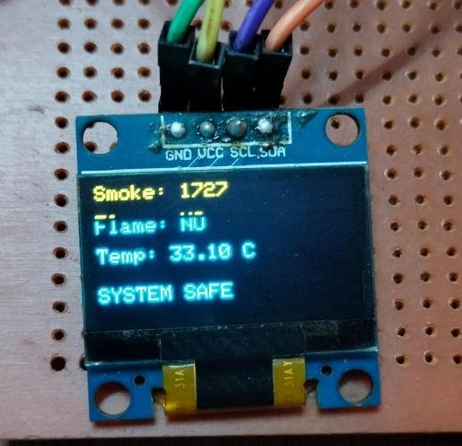
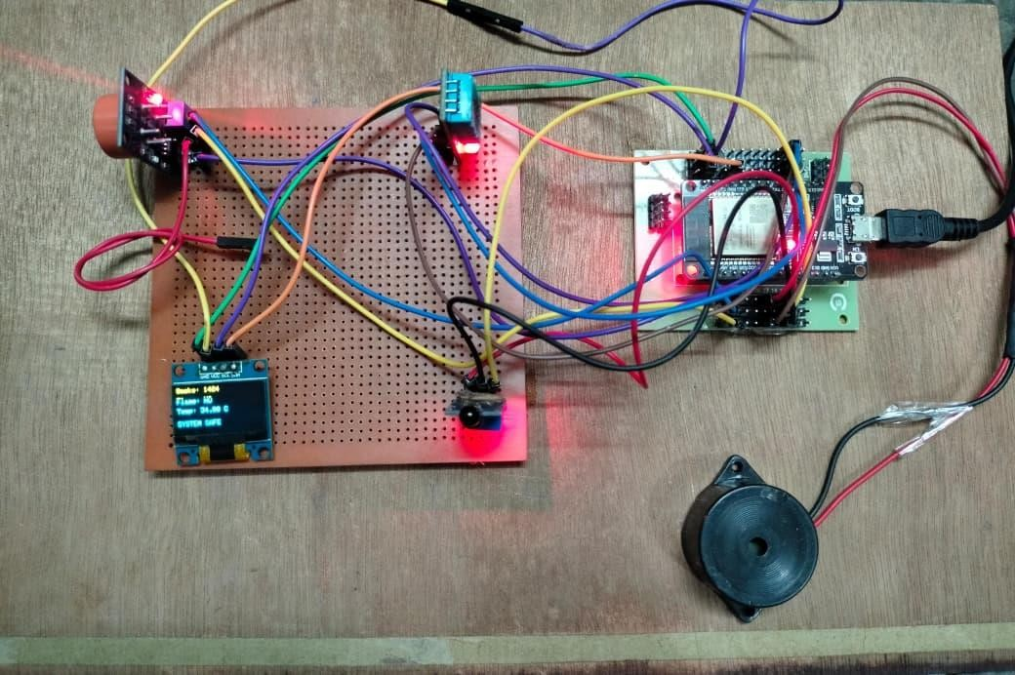
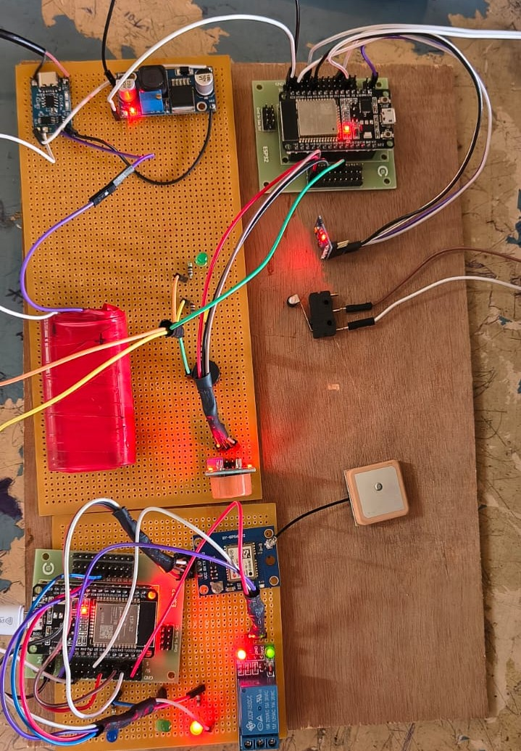
FIG.3.5 WORKING MODEL OF PROJECT

